॥ सत्यं ज्ञानमनन्तम् ॥ ISSN (NISCAIR) NO : ISSN 2250-1711
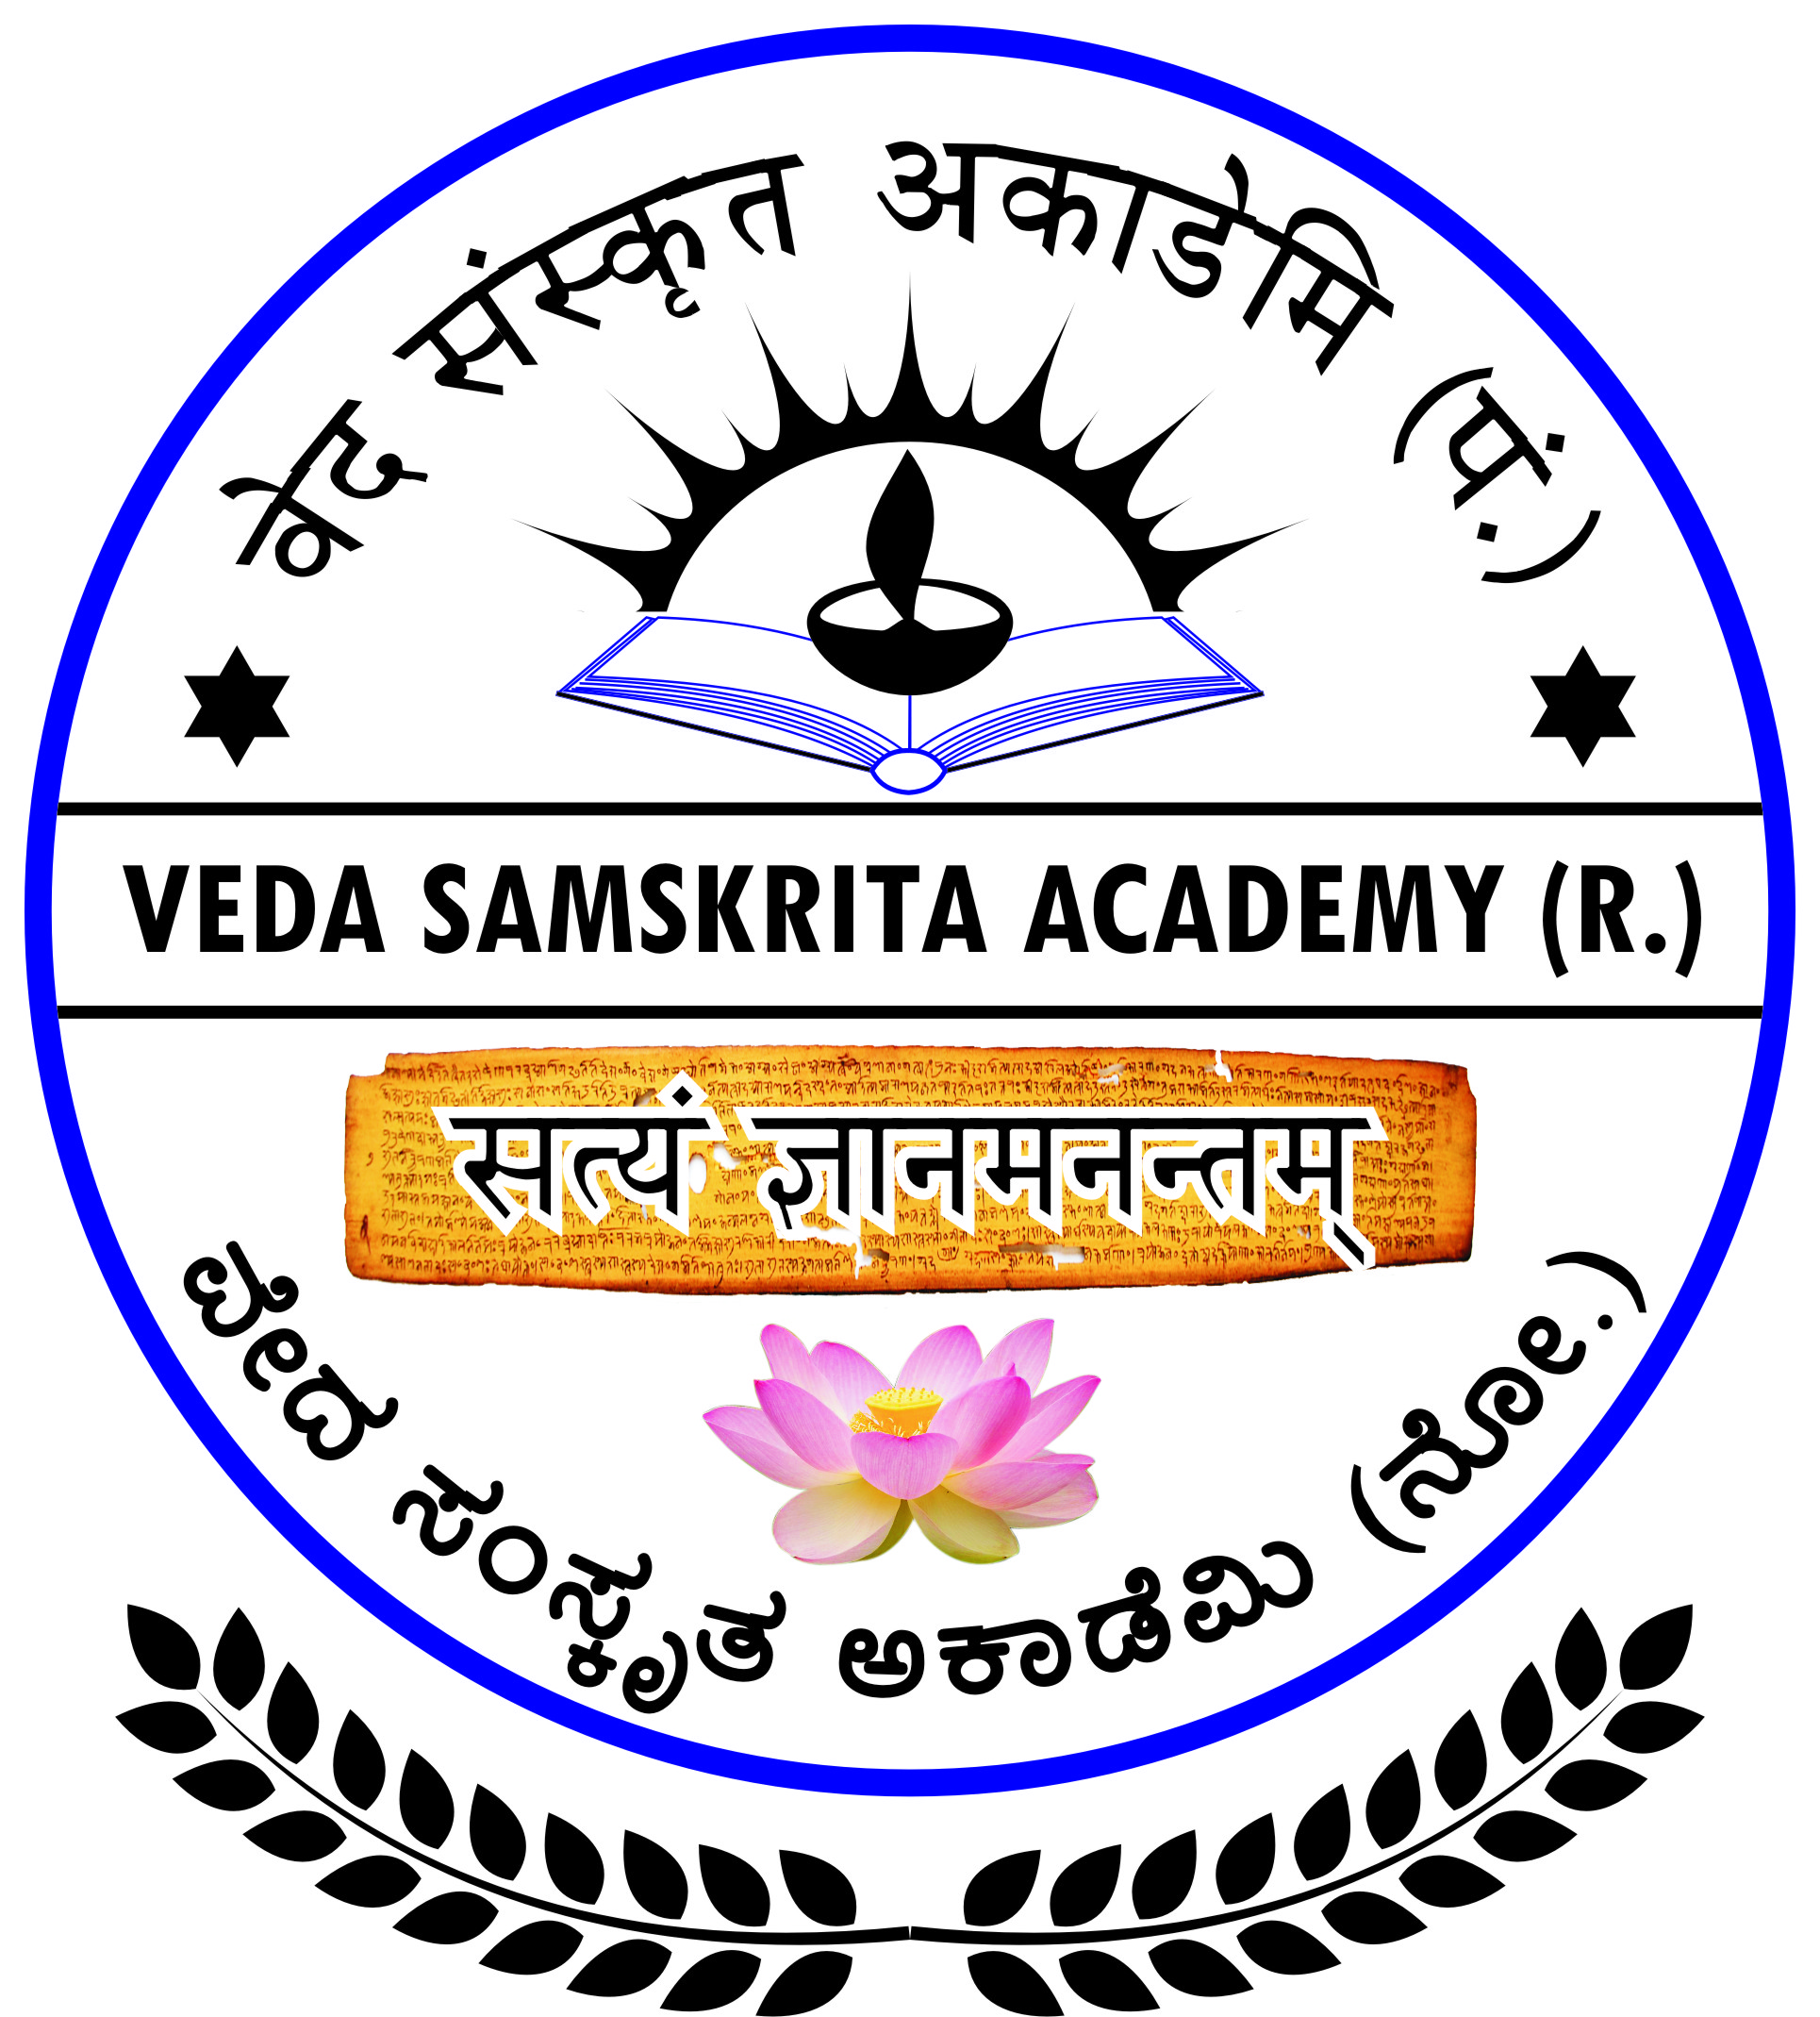 |  | वेद संस्कृत अकाडेमि (पं.)  ವೇದ ಸಂಸ್ಕೃತ ಅಕಾಡೆಮಿ (ನೋಂ.), ಹೆಗಡೆ  VEDA SAMSKRITA ACADEMY (Regd.)  Formerly : Veda Samskrita Prasarinee Sabha (R.)  Regd. No. : DR:SOR:108:2003-04, Dated : 30-10-2003  Registered under Societies Registration Act, of Karnataka-1960

Registered office address :
# 1347, Kalkod Road, HEGDE-581330, Kumta, Uttarakannada, Karnataka, India

E-mail ID : vedasmkac@gmail.com Website : www.vedasamskritaacademy.org Contact No. : 9741847399
----------------------------------------------------------------------------------------------------------------------------------------
Ref. No. : jvsa /26/2024 Date : 03-12-2024

NOTIFICATION
I would like to bring to the kind notice of the contributors of articles of our “Journal of Veda Samskrita Academy” that, from July 2023, name of our journal has been deleted from the UCG CARE List. This development has been noticed from the UGC website.
No correspondance has been made with the Academy in this regard. We do not know the exact reason for the non-inclution of our journal in the CARE List. However, our effort for the inclusion in the CARE List is in progress. If any lapse is there from our side, we will try to set right the short comings. This work may not be completed before December, 2024.
In this regard we would like to inform yoy that 24th volume, i.e. from July to December 2024 will be published as usual, National Peer-Reviewed Research Journal, with ISSN 2250-1711 only, without UGC CARE List identity.
Last date for the submission of articles is 25th December 2024. Publication of the Journal will be in the month of February 2025. Contributors of articles may kindly note this and co-operate as earlier.
With Regards,
Place : Hegde
Date : 03-12-2024
Dr. Gopalkrishna Hegde
Director & Editor-in-chief
Veda Samskrita Academy (Regd.)
# 1347, Kalkod Road, P. O. : HEGDE-581330
Kumta, Uttarakannada, Karnataka
Contact No. : 9741847399
E-mail : vedasmkac@gmail.com

